Lab#10 Create a responsive web page of your Product page using Tailwind CSS only.

Final Outcome:
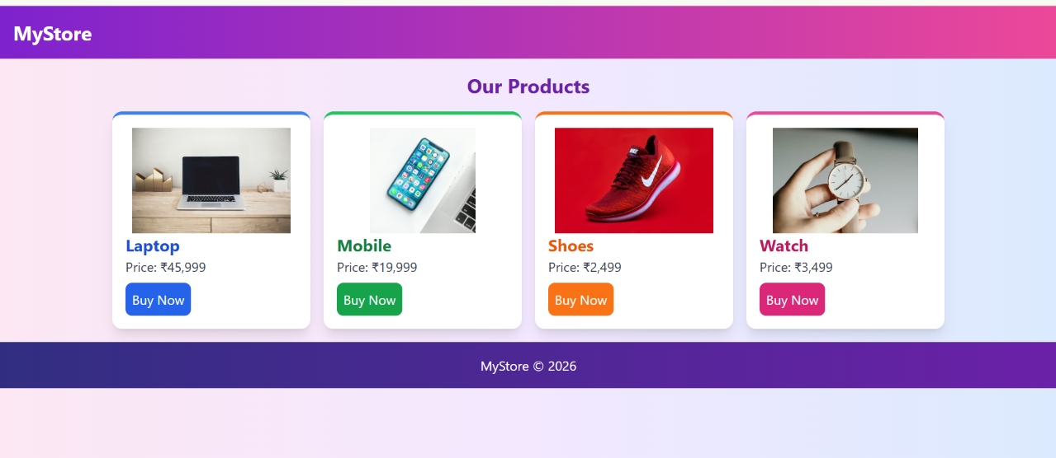

Code Snippet:

<!DOCTYPE html>
<html>
<head>
<title>Product Page</title>
<script src="https://cdn.tailwindcss.com"></script>
</head>

<body class="bg-gradient-to-r from-pink-100 via-purple-100 to-blue-100">

<!-- Header -->
<header class="bg-gradient-to-r from-purple-700 to-pink-500 text-white p-4">
<h1 class="text-2xl font-bold">MyStore</h1>
</header>

<!-- Products -->
<div class="p-4">
<h2 class="text-2xl text-center mb-4 text-purple-800 font-bold">
Our Products
</h2>

<div class="flex flex-wrap justify-center gap-4">

<!-- Product 1 -->
<div class="bg-white p-4 w-60 rounded-xl shadow-lg border-t-4 border-blue-500">
<img src="https://images.unsplash.com/photo-1496181133206-80ce9b88a853?w=400"
class="w-full h-32 object-contain rounded-lg"
alt="Laptop">

<h3 class="text-xl text-blue-700 font-bold">Laptop</h3>
<p class="text-gray-700">Price: ₹45,999</p>
<button class="bg-blue-600 hover:bg-blue-800 text-white p-2 mt-2 rounded-lg">
Buy Now
</button>
</div>

<!-- Product 2 -->
<div class="bg-white p-4 w-60 rounded-xl shadow-lg border-t-4 border-green-500">
<img src="https://images.unsplash.com/photo-1511707171634-5f897ff02aa9?w=400"
class="w-full h-32 object-contain rounded-lg"
alt="Mobile">

<h3 class="text-xl text-green-700 font-bold">Mobile</h3>
<p class="text-gray-700">Price: ₹19,999</p>
<button class="bg-green-600 hover:bg-green-800 text-white p-2 mt-2 rounded-lg">
Buy Now
</button>
</div>

<!-- Product 3 -->
<div class="bg-white p-4 w-60 rounded-xl shadow-lg border-t-4 border-orange-500">
<img src="https://images.unsplash.com/photo-1542291026-7eec264c27ff?w=400"
class="w-full h-32 object-contain rounded-lg"
alt="Shoes">

<h3 class="text-xl text-orange-600 font-bold">Shoes</h3>
<p class="text-gray-700">Price: ₹2,499</p>
<button class="bg-orange-500 hover:bg-orange-700 text-white p-2 mt-2 rounded-lg">
Buy Now
</button>
</div>

<!-- Product 4 -->
<div class="bg-white p-4 w-60 rounded-xl shadow-lg border-t-4 border-pink-500">
<img src="https://images.unsplash.com/photo-1524592094714-0f0654e20314?w=400"
class="w-full h-32 object-contain rounded-lg"
alt="Watch">

<h3 class="text-xl text-pink-700 font-bold">Watch</h3>
<p class="text-gray-700">Price: ₹3,499</p>
<button class="bg-pink-600 hover:bg-pink-800 text-white p-2 mt-2 rounded-lg">
Buy Now
</button>
</div>

</div>
</div>

<!-- Footer -->
<footer class="bg-gradient-to-r from-indigo-900 to-purple-800 text-white text-center p-4">
MyStore © 2026
</footer>

</body>
</html>

